**Linux command Practice 3**

**File Management:**

**Create, rename, or delete multiple files based on a pattern or criteria.**

**Create multipleFiles :**

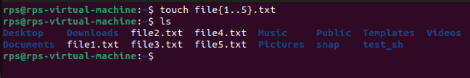

**Rename multipleFiles :**

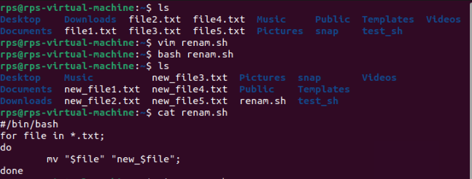

**Delete multipleFiles :**

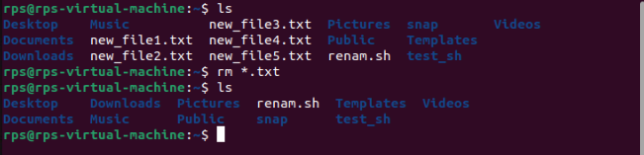

**Organize files into a specific directory structure.**

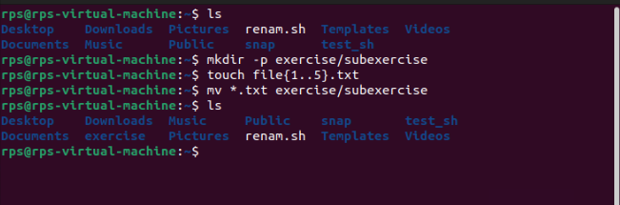

**Back up or archive important files.**

**Backup File :**

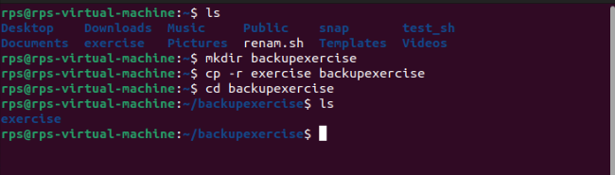

**Archive File:**

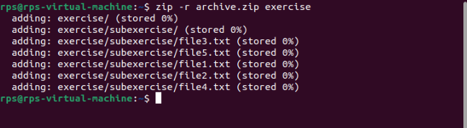

**Text Processing:**

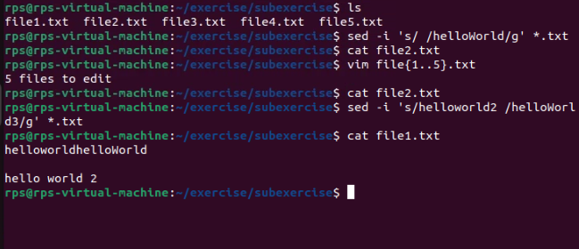

**Search and replace text within a group of files.**

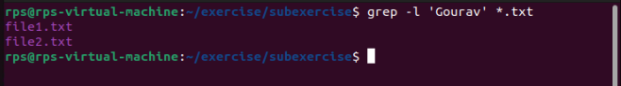

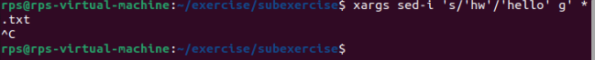

**Extract specific information from log files or data sets.**

**Format text files in a particular way**

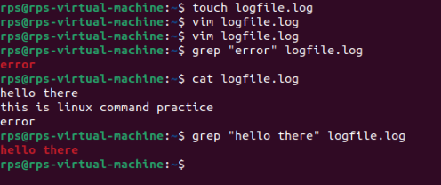

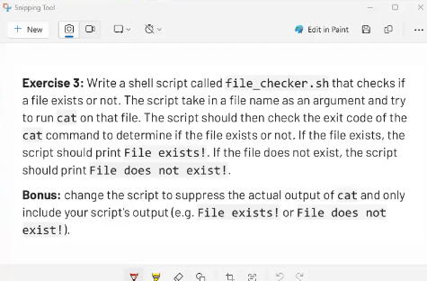

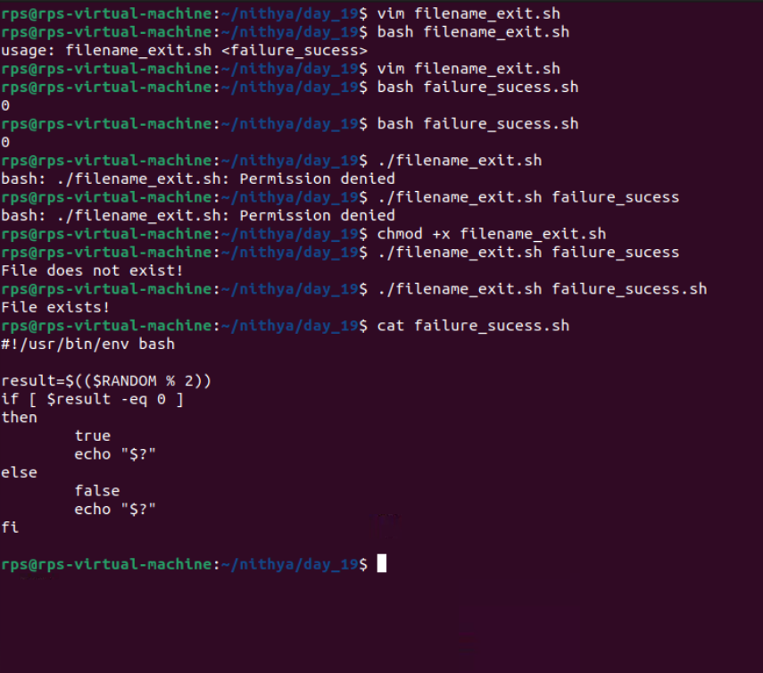

**Bash file to do a arthamatic operation**